**Dimbakis Project**

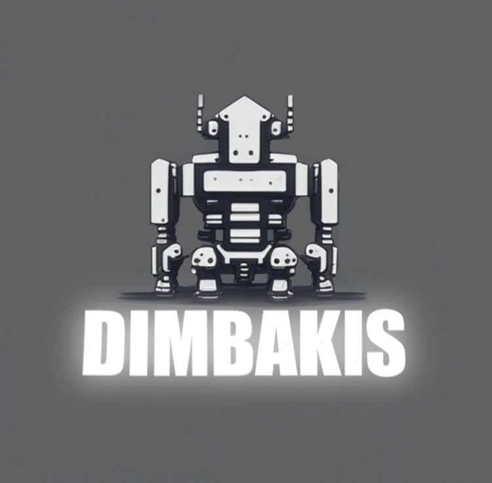

**Dimbakis Project**

Idea of the project: To create a site that shows the future of robots in space exploration

TEAM MEMBERS

|  |  |
| --- | --- |
| № | Roles in the team |
| 1 | Milan Nedelchev– Scrum trainer |
| 2 | Dimitur Kostadinov – Front-end developer |
| 3 | Stiliyan Dimitrov - Front-end developer |
| 4 | Kalina Atanasova – Designer |

PROJECT DESCRIPTION

|  |  |
| --- | --- |
| № | Description |
| 1 | The Idea  The idea is, a site that shows the future of robotics in space exploration. |
| 2 | How can you access the project?  You can find our project on GitHub. You can access the files by installing the repository, or paste this to your console – git clone https://github.com/MPNedelchev22/Dimbakis-Project.git |
| 3 | Teamwork.  Our main communicating platform was Microsoft Teams. We made plan, so everybody could work. |
| 4 | What technologies are used?  The technologies used are **Visual Studio Code** as our code editor, we used **GitHub** for collaborative work, **Microsoft Teams** - connection and communication, **PowerPoint** - preparing a Presentation, **Word** - preparing Documentation. |

**Dimbakis Project**

|  |  |
| --- | --- |
| № | Completed tasks |
| 1 | Make a design for the site  Our designer was given the task to figure out a good design and she did it. |
| 2 | Write the HTML code for the pages  Our front-end developers made the HTML code for the pages on our site. |
| 3 | Write the CSS code for the pages  Me and our front-end developers wrote the CSS code for the pages on our site |
| 4 | Make the README file  In the readme file you can get a quick overview of the project. We have added the programming languages we used, the diagrams and the demos of the project. |
| 5 | Make the documentation  The documentation provides very useful information in terms of the technical aspect. You can learn pretty much everything by reading it. |
| 6 | Make the presentation  We have created a short presentation to quickly show what we have done. |